


(With a one small catch…)

But First, Check out what kind of changes you can expect

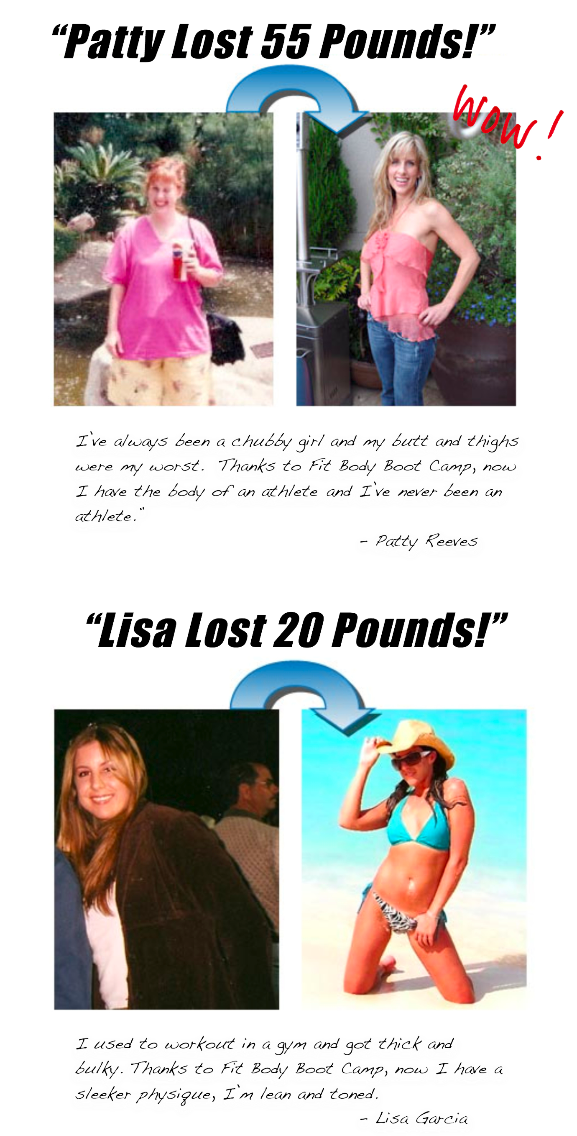

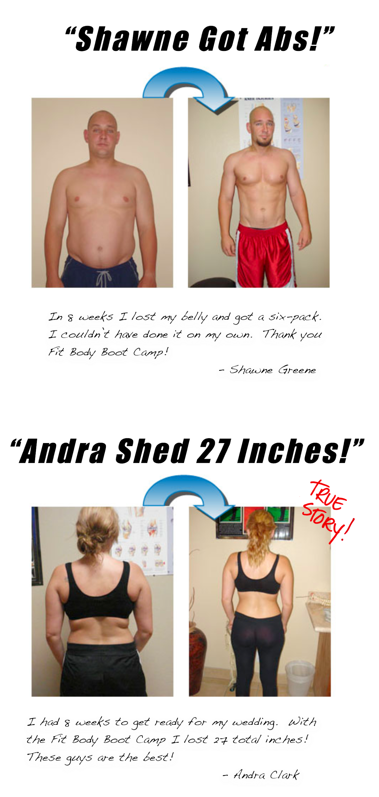
Steve, this all sounds great but what’s the CATCH?

Here’s the catch, since I’m sick and tired of paying up the wazoo for marketing,
I’ve decided to try something out-of-the-box.

So I’m taking on 20 FREE clients to be my walking, talking “human Billboards.”
Well, not exactly free, your job is to get stronger, leaner and sexier, and then
tell everyone about my boot camp.

Here’s how you can qualify to be one of the first 20.


- You must promise to have a positive attitude and work your butt off at my boot camp!
- You must promise to show up at least 3x’s per week to my boot camp!
- You must not be a past or current member of Fit Body Boot Camp!
- You must promise to refer me 1 boot camp client per month (No exceptions!)
I only have 20 slots to fill, so please DO NOT respond to this ad and take someone’s spot if you can’t meet my qualifications.

Ok Steve, I qualify! Now, what do I do next?

The next step is to reply to this ad with your

Name, phone number and the location you would like to attend

But hurry, I’m going to post this ad all over craigslist, and I’m only taking the first 20!

Here’s the location and schedue:

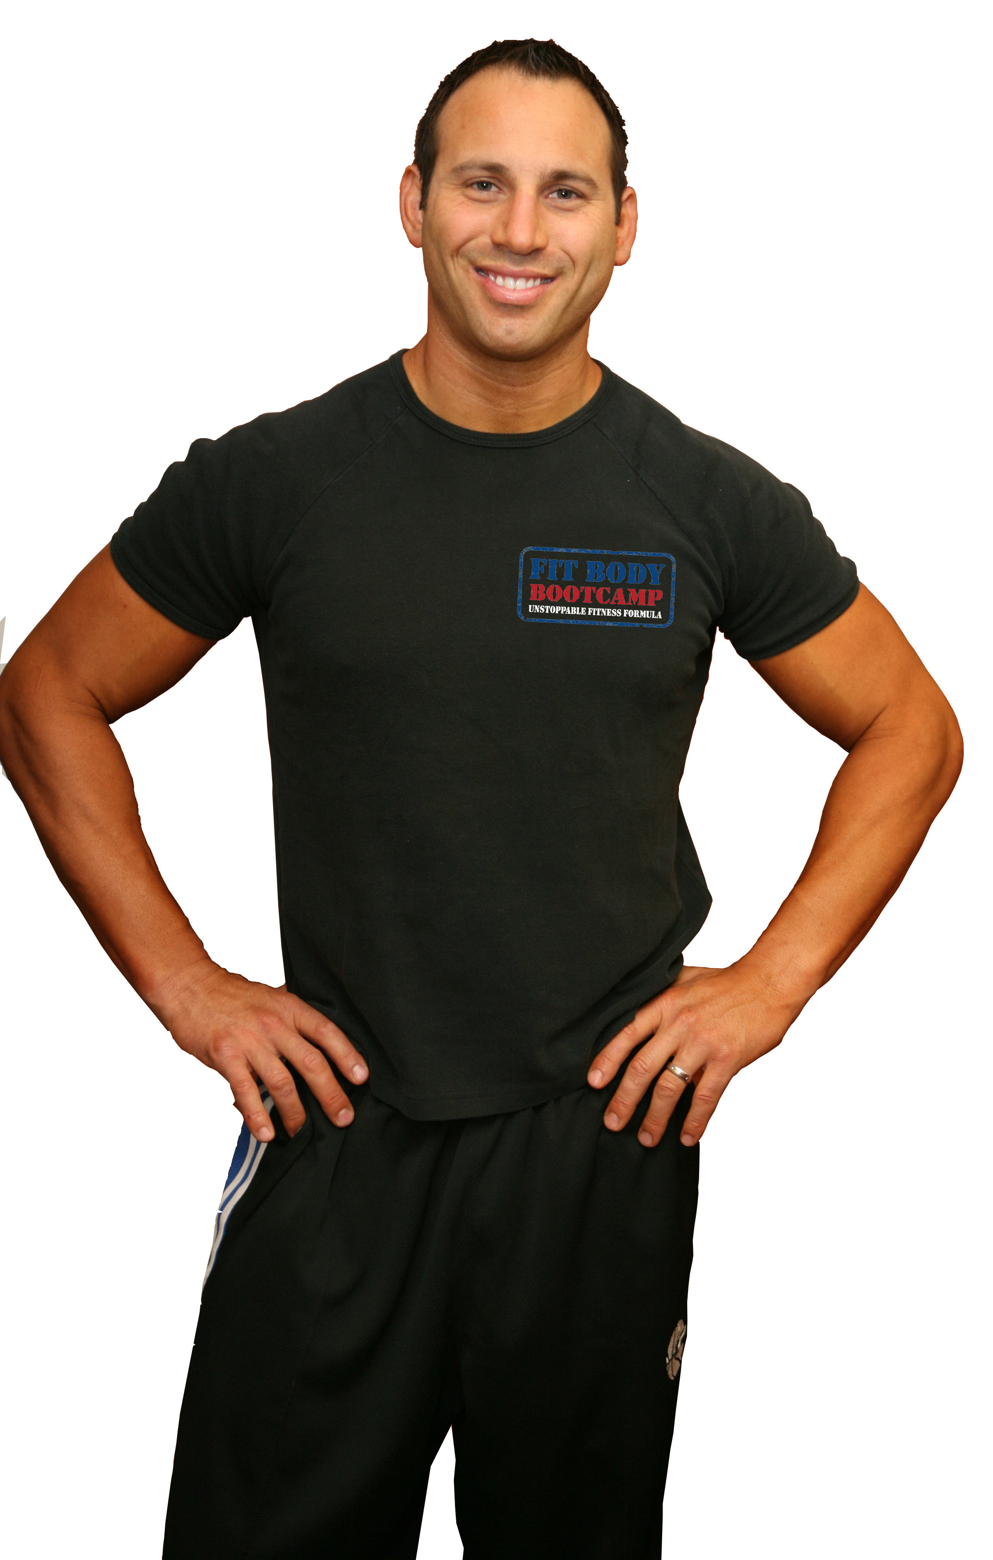
Rancho Santa Margarita
22233 Margarita Dr.
(Inside OC All-Stars)
Monday – Friday
5:30am and 9:00am
Saturday 8:00am

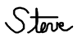

30 days from now you’ll be 1 month older and possible 3-7 Lbs heaver – Or you could be 5-10Lbs lighter, 10x’s stronger and 30 days closer to your feeling and looking your very best ever!
If you qualify, be sure to make the smart decision and reply back with your name, phone number and location today… You’ll be so glad you did!

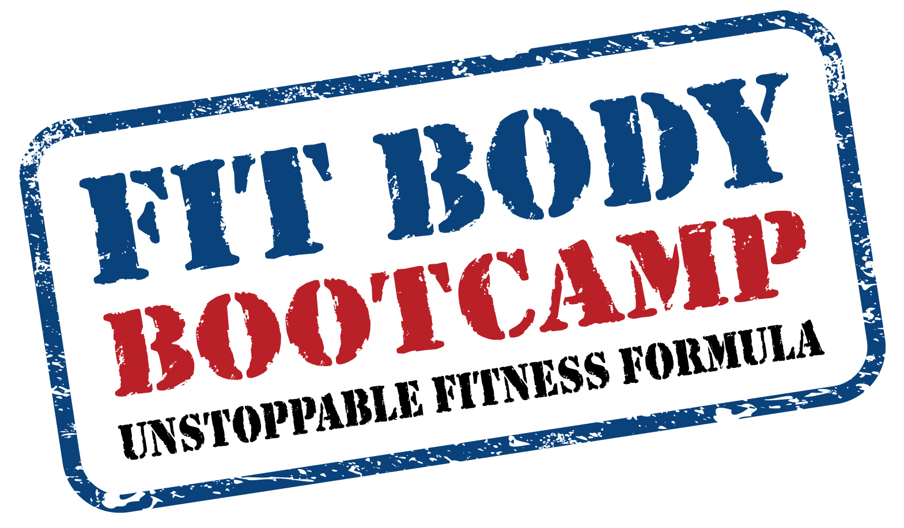
Steve Hochman BCTS
Fit Body Boot Camp

